**Capital Improvement Sales Tax Fund**

|  |  |
| --- | --- |
| **Project Name:**  **Second Creek Sidewalks** | **Department:**  **Public Works** |
| **Type of Project:**  **New Infrastructure** | **Contact**:  **Chuck Soules** |
| **Total Project Cost:**  **$1,300,000** | |

**Description:**

This project includes an 8-foot multi-use path along Second Creek (from Highway 169 to Wright Valley Road) to connect to residential neighborhoods. Currently, there is no sidewalk in the area and the curve creates a blind spot for pedestrians and drivers. The multi-use path will be ADA accessible and provide safe access for pedestrians and bicyclists to the downtown amenities, trails, and parks. The bridge over the Little Platte River will be widened to provide pedestrian access across the river.

**Justification:**

The City of Smithville applied for a grant from MARC (Mid-America Regional Council) in 2022 to fund the proposed sidewalk project, and the City was awarded this grant. As identified in the City's Transportation Master Plan, several short sidewalk connections are needed throughout Smithville to connect between neighborhoods and other destinations. Residents have multimodal options within their own neighborhood, but do not have the infrastructure to safely travel to other destinations. The need for more sidewalks and multi-use paths emerged as a major theme in the Transportation Master Plan.

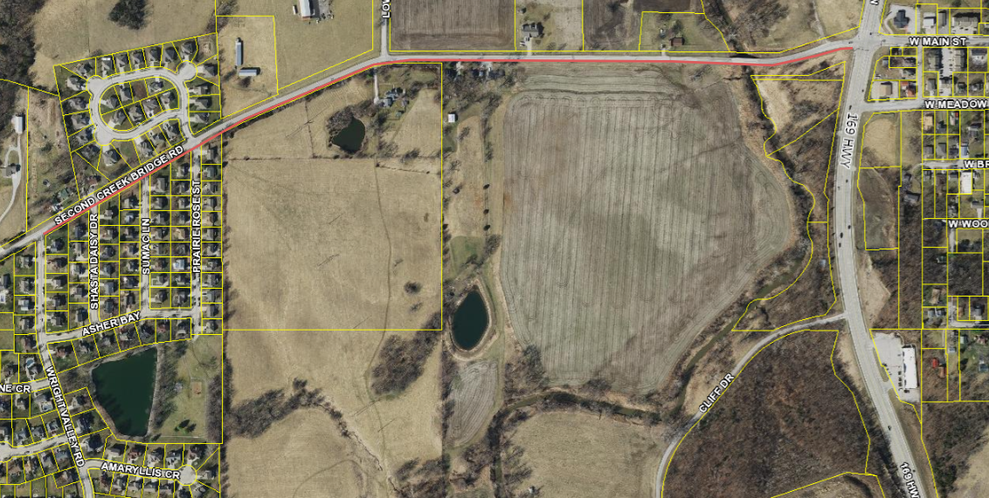

**Planned Expenditures**

|  |  |  |
| --- | --- | --- |
|  | **FY2026** | **Total** |
| **Engineering** | **$50,000** | **$50,000** |
| **Construction** | **$1,250,000** | **$1,250,000** |
| **Total** | **$1,300,000** | **$1,300,000** |

**Funding Sources**

|  |  |  |
| --- | --- | --- |
|  | **FY2026** | **Total** |
| **Capital Improvement Sales Tax** | **$1,300,000** | **$1,300,000** |
| **MARC Grant**  **(Reimbursement)** | **($600,000)** | **($600,000)** |
| **Total Net Cost** | **$900,000** | **$900,000** |